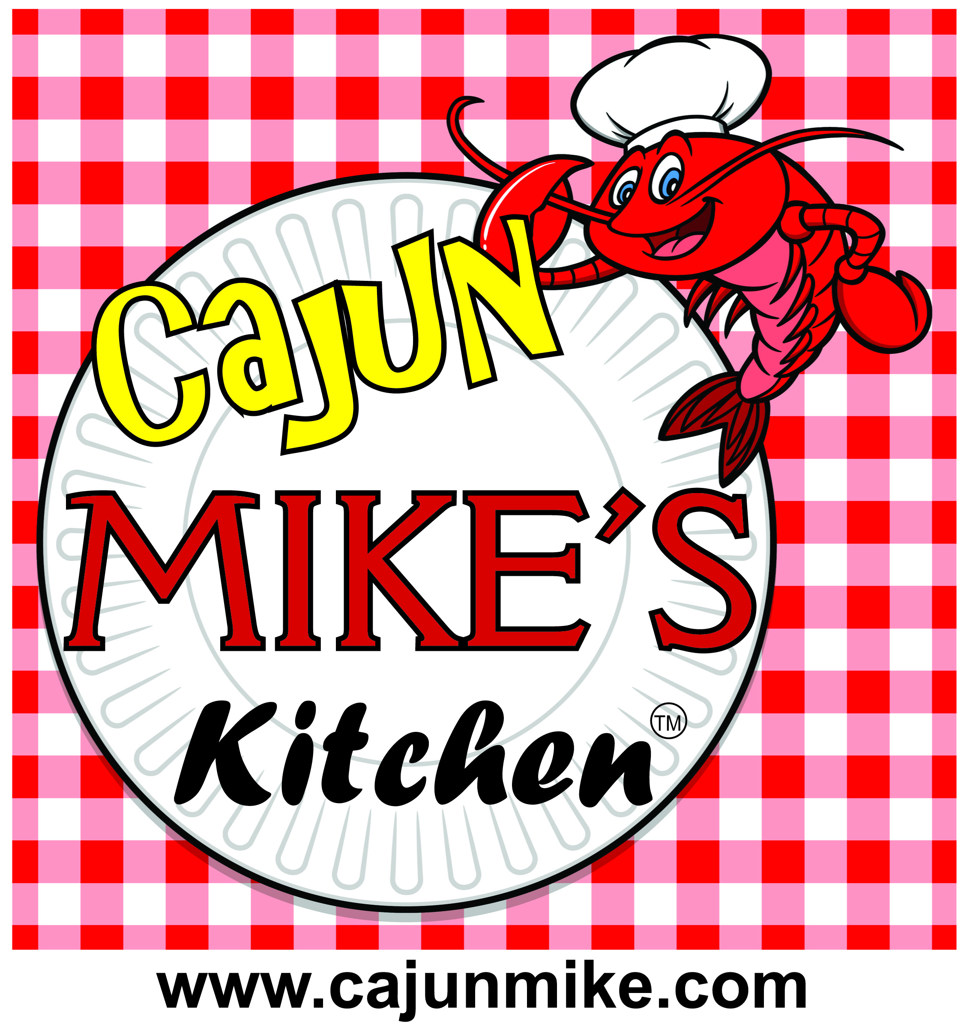

**504-722-2500**

**Chef Cajun Mike’s Cajun Extravaganza**

**Royal Package - $250.00 Per Person**

**Seafood Station**- Cracked Lobster Claws, Boiled Shrimp, Charbroiled Oysters, Oysters on Half- Shell

**Carving Station**- Smoke Brisket or Roast Beef ( **Prime Rib - additional Cost Market Price**)

**Soup Station**- **( Choose Three**) - Creole Seafood Gumbo, Chicken Sausage Gumbo, Crawfish Corn Chowder, Shrimp Corn Chowder, Chicken Corn Chowder or Cajun Seafood Soup.

**Appetizer Station** – **( Choose Five)** - New Orleans Style Crab Cakes, Bacon Wrapped Shrimp and Scallops, Crawfish Pies, Boudin Balls,Catfish Bites, Chicken Bites, Fry Shrimp, Fried Oysters, Steak Kebabs, Finger Sandwiches and Mini New Orleans Style Muffalattas, Creole Meatballs. Hot Wings or Fried Chicken Drummettes.

**Vegan and Lactose Free Station**- Vegan-Creole Pasta , Vegan & Lactose Free- Red beans & Rice, Smothered Corn and Green Beans and Cabbage.

**Entree – (Choose Five)**. - Chicken & Sausage Jambalaya, Shrimp & Sausage Jambalaya, Crawfish & Sausage Jambalaya, Crawfish Etouffee, Shrimp Etouffee, Shrimp Creole, Shrimp and Grits, Grillades & Grits, Shrimp Pasta Josephine, Chicken Creole, Chicken Pasta Josephine, Creole Meatball Spaghetti.

**Entrée Sides Station** - Corn Maique Choux, Smothered Cabbage and Creole Style Smothered Green Beans

**Salad Station** – Spring Organic Salad, Potato and Tuna Salad

**Fruit and Veggie Station** - Fresh Fruits and Raw Vegetable’s

**Desert Station –** New Orleans Style Bread Pudding, Vanilla Pudding and Various Pies

**\*\* Soft Drinks, Tea , Coffee and Water Included \*\***

**\*\* All Menu Dishes can be Substituted from our all of Our Main Menus \*\***

**\*\* Does not Includes Plates, Silver Wear, Cups and Paper Products \*\*\***

**King’s Package - $150.00 Per Person**

**Seafood Station**- Boiled Shrimp

**Carving Station**- Smoke Brisket or Roast Beef - ( **Prime Rib - additional Cost Market Price** )

**Soup Station**-  **(Choose Two**) - Creole Seafood Gumbo, Chicken Sausage Gumbo, Crawfish Corn Chowder, Shrimp Corn Chowder, Chicken Corn Chowder or Cajun Seafood Soup or Cajun Chicken & Vegetable Soup

**Appetizer Station** – **(Choose Four)** - New Orleans Style Crab Cakes, Bacon Wrapped Shrimp and Scallops, Crawfish Pies, Boudin Balls, Catfish Bites, Chicken Bites, Fry Shrimp, Fried Oysters, Steak Kebabs, Finger Sandwiches and Mini New Orleans Style Muffalattas, Creole Meatballs, Hot Wings or Fried Chicken Drummettes.

**Vegan and Lactose Free Station**- **(Choose Three) -**  Vegan-Creole Pasta , Vegan & Lactose Free- Red beans & Rice, Smothered Corn and Green Beans and Cabbage.

**Entrees – ( Choose 4 )** - Chicken or Shrimp & Sausage Jambalaya, Crawfish or Shrimp Etouffee , Shrimp Creole, Shrimp and Grits, Shrimp Pasta Josephine, Chicken Creole, Chicken Pasta Josephine, Creole Meatball Spaghetti

**Entrée Sides Station** - Corn Maique Choux, Smothered Cabbage and Creole Style Smothered Green Beans

**Salad Station** – Spring Organic Salad, Potato

**Fruit and Veggie Station** - Fresh Fruits and Raw Vegetable’s

**Desert Station –** New Orleans Style Bread Pudding, Vanilla Pudding and Various Pies

Soft Drinks, Tea, Coffee and Water Included

**\*\* All Menu Dishes can be Substituted from our all of Our Main Menus \*\***

**\*\* Does not Includes Plates, Silver Wear, Cups and Paper Products \*\*\***

**Queens Package - $125.00 Per Person**

**Seafood Station**- Boiled Shrimp

**Carving Station**- Smoke Brisket or Roast Beef - ( **Prime Rib - additional Cost Market Price** )

**Soup Station**-  **(Choose Two**) - Creole Seafood Gumbo, Chicken Sausage Gumbo, Crawfish Corn Chowder, Shrimp Corn Chowder, Chicken Corn Chowder or Cajun Seafood Soup or Cajun Chicken & Vegetable Soup..

**Appetizer Station** – **(Choose Three)** - New Orleans Style Crab Cakes, Bacon Wrapped Shrimp and Scallops, Crawfish Pies, Boudin Balls,Catfish and Chicken Bites, Fry shrimp & Oysters, Steak Kebabs, Finger Sandwiches and Mini New Orleans Style Muffalattas, Creole Meatballs, Chicken Drumettes or Hot Wings

**Vegan and Lactose Free Station**- **(Choose Three) -**  Vegan-Creole Pasta , Vegan & Lactose Free- Red beans & Rice, Smothered Corn and Green Beans and Cabbage.

**Entrees – ( Choose 3 )** Chicken or Shrimp & Sausage Jambalaya, Crawfish and Shrimp Etouffee , Shrimp Creole, Shrimp and Grits, Shrimp Pasta Josephine, Chicken Pasta Josephine, Chicken Creole over Rice, Creole Meatball Spaghetti

**Entrée Sides Station** - Corn Maique Choux, Smothered Cabbage and Creole Style Smothered Green Beans

**Salad Station** – Spring Organic Salad, Potato Salad

**Fruit and Veggie Station** - Fresh Fruits and Raw Vegetable’s

**Desert Station –** New Orleans Style Bread Pudding, Vanilla Pudding and Various Pies

Soft Drinks, Tea, Coffee and Water Included

**\*\* All Menu Dishes can be Substituted from our all of Our Main Menus \*\***

**\*\* Does not Includes Plates, Silver Wear, Cups and Paper Products \*\*\***

**Prince Package - $100.00 Per Person**

**Carving Station**- Smoke Brisket or Roast Beef - ( **Prime Rib - additional Cost Market Price** )

**Soup Station**-  **(Choose One**) - Creole Seafood Gumbo, Chicken Sausage Gumbo, Crawfish Corn Chowder, Shrimp Corn Chowder, Chicken Corn Chowder , Cajun Seafood Soup or Cajun Chicken & Vegetable Soup.

**Appetizer Station** – **(Choose Two)** - New Orleans Style Crab Cakes, Bacon Wrapped Shrimp and Scallops, Crawfish Pies, Boudin Balls,Catfish and Chicken Bites, Fry shrimp & Oysters, Steak Kebabs, Finger Sandwiches and Mini New Orleans Style Muffalattas, Creole Meatballs, Chicken Drumettes or Hot Wings

**Vegan and Lactose Free Station**- **(Choose Two) -**  Vegan-Creole Pasta , Vegan & Lactose Free- Red beans & Rice, Smothered Corn and Green Beans and Cabbage.

**Entrees – ( Choose 3 )** Chicken or Shrimp & Sausage Jambalaya, Crawfish or Shrimp Etouffee , Shrimp Creole, Shrimp and Grits, Shrimp Pasta Josephine, Chicken Pasta Josephine, Chicken Creole or Creole Meatball Spaghetti

**Salad Station** – Spring Organic Salad, Potato Salad

**Fruit and Veggie Station** - Fresh Fruits and Raw Vegetable’s

**Desert Station –** New Orleans Style Bread Pudding, Vanilla Pudding and Various Pies

Soft Drinks, Tea, Coffee and Water Included

**\*\* All Menu Dishes can be Substituted from our all of Our Main Menus \*\***

**\*\* Does not Includes Plates, Silver Wear, Cups and Paper Products \*\*\***

**Princes Package - $75.00 Per Person**

**Soup Station**-  **(Choose One**) - Creole Seafood Gumbo, Chicken Sausage Gumbo, Crawfish Corn Chowder, Shrimp Corn Chowder, Chicken Corn Chowder or Cajun Seafood Soup or Cajun Chicken & Vegetable Soup.

**Appetizer Station** – **(Choose Two)** - New Orleans Style Crab Cakes, Bacon Wrapped Shrimp and Scallops, Crawfish Pies, Boudin Balls,Catfish and Chicken Bites, Fry shrimp & Oysters, Steak Kebabs, Finger Sandwiches and Mini New Orleans Style Muffalattas , Creole Meatballs, Chicken Bites, Paned Fried Chicken Drumettes or Hot Wings

**Vegan and Lactose Free Station**- **(Choose Two) -**  Vegan-Creole Pasta , Vegan & Lactose Free- Red beans & Rice, Smothered Corn and Green Beans and Cabbage.

**Entrees – ( Choose 3 )** Chicken or Shrimp & Sausage Jambalaya, Crawfish and Shrimp Etouffee , Shrimp Creole, Shrimp and Grits, Shrimp Pasta Josephine, Chicken Pasta Josephine, Chicken Etouffee, Chicken Creole or Creole Meatball Spaghetti.

**Salad Station** – Spring Organic Salad, Potato Salad

**Fruit and Veggie Station** - Fresh Fruits and Raw Vegetable’s

**Desert Station –** New Orleans Style Bread Pudding, Vanilla Pudding and Various Pies

Soft Drinks, Tea, Coffee and Water Included

**\*\* All Menu Dishes can be Substituted from our all of Our Main Menus \*\***

**\*\* Does not Includes Plates, Silver Wear, Cups and Paper Products \*\*\***

**Knights Package - $ 50.00 Per Person**

**Soup Station**-  **(Choose One**) - Chicken and Sausage Gumbo , Chicken Corn Chowder, Creole Vegetable and Beef Soup, Cajun Chicken & Vegetable Soup

**Appetizer Station** – **(Choose One)** - Boudin Balls, Chicken Bites, Finger Sandwiches, New Orleans Style Muffalattas. Creole Meatballs, Chicken Bites, Paned Fried Chicken Drumettes or Hot Wings

**Entrees – ( Choose 2 )** Chicken & Sausage Jambalaya, Chicken Etouffee, Grillades & Grits, Chicken Pasta Josephine, Chicken Creole, Creole Meatball Spaghetti or Red Beans and Rice.

**Salad Station** – Spring Organic Salad, Potato Salad.

**Desert Station –** New Orleans Style Bread Pudding, Vanilla Pudding and Various Pies

**\*\*\* Soft Drinks, Tea, Coffee and Water Not Included \*\***

**\*\* All Menu Dishes can be Substituted from our all of Our Main Menus for an Additional Cost\*\***

**\*\* Does not Includes Plates, Silver Wear, Cups and Paper Products \*\*\***

**Pawn Package - $ 35.00 Per Person**

**Soup**   **(Choose One)** - Chicken and Sausage Gumbo, Chicken Corn Chowder, Creole Vegetable and Beef Soup or Cajun Chicken & Vegetable Soup.

**Appetizer** – **(Choose One)** – Creole Meatballs, Finger Sandwiches, Mini New Orleans Style Muffalattas, Chicken Bites, Paned Fried Chicken Drumettes , Hot Wings.

.

**Entrees – ( Choose 1 )** Chicken & Sausage Jambalaya, Crawfish and Chicken Etouffee Over Rice , Chicken Creole over Rice, Grillades and Grits, Chicken Pasta Josephine, Creole Meatball Spaghetti, Red Beans and Rice

**Salad -** – Spring Organic Salad, Potato Salad.

**Desert Station –( Choose 1 )** New Orleans Style Bread Pudding, Vanilla Pudding and Various Pies

**\*\*\* Soft Drinks, Tea, Coffee and Water Not Included \*\***

**\*\* All Menu Dishes can be Substituted from our all of Our Main Menus for an Additional Cost\*\***

**\*\* Does not Includes Plates, Silver Wear, Cups and Paper Products \*\*\***